Jenkins provides various plugins to generate build reports, which help you to analyze the results of your build process. Here are some of the popular plugins used to generate build reports in Jenkins:

1. TestNG Plugin - This plugin generates test reports based on TestNG test results. It provides a graphical view of the test results, including pass/fail status, test duration, and error messages.
2. JUnit Plugin - This plugin generates test reports based on JUnit test results. It provides a graphical view of the test results, including pass/fail status, test duration, and error messages.
3. Cobertura Plugin - This plugin generates code coverage reports based on Cobertura coverage results. It provides a graphical view of the code coverage, including the percentage of lines covered by tests, branches covered by tests, and classes covered by tests.
4. Checkstyle Plugin - This plugin generates code quality reports based on Checkstyle analysis results. It provides a graphical view of the code quality issues, including coding style violations, potential bugs, and performance issues.
5. FindBugs Plugin - This plugin generates code quality reports based on FindBugs analysis results. It provides a graphical view of the code quality issues, including potential bugs, performance issues, and security vulnerabilities.

To install a plugin, go to the "Manage Jenkins" page and click on "Manage Plugins." Then, search for the plugin you want to install and click on the "Install" button.

Once you have installed a plugin, you can configure it to generate reports based on the results of your build process. The reports can be accessed by clicking on the "Build Reports" link in the left-hand menu of the Jenkins dashboard.

The Checkstyle plugin in Jenkins is used to generate code quality reports based on Checkstyle analysis results. Checkstyle is a static code analysis tool that checks Java code against a set of coding standards and guidelines. The Checkstyle plugin can be used to analyze Java code in Jenkins and generate reports that highlight code quality issues and identify areas where code improvements can be made.

To set up the Checkstyle plugin in Jenkins, follow these steps:

1. Log in to your Jenkins server and go to the "Manage Jenkins" page.
2. Click on the "Manage Plugins" link and search for the Checkstyle plugin.
3. Select the Checkstyle plugin and click on the "Install" button.
4. Once the installation is complete, restart Jenkins to activate the plugin.
5. Create a new Jenkins job or open an existing one that has Java code.
6. In the job configuration, go to the "Build" section and add a new build step to execute the Checkstyle analysis. You can do this by adding a "Execute Shell" build step and running the following command:

checkstyle -c checkstyle.xml your-java-code-dir

This command will run the Checkstyle analysis on your Java code in the specified directory using the **checkstyle.xml** configuration file.

1. In the job configuration, go to the "Post-build Actions" section and click on the "Add post-build action" button.
2. Select the "Publish Checkstyle analysis results" option from the list of available post-build actions.
3. In the "Checkstyle results" field, enter the following path:

bashCopy code

**/checkstyle-result.xml

This path will look for the Checkstyle report file in the workspace directory of the Jenkins job.

1. Optionally, you can configure other options for the Checkstyle report, such as the minimum priority for issues to include in the report.
2. Save your changes to the job configuration.
3. Run the job to generate the Checkstyle report. The Checkstyle report can be accessed by clicking on the "Checkstyle Warnings" link in the left-hand menu of the Jenkins dashboard.

That's it! You should now have the Checkstyle plugin set up in Jenkins and generating reports for your Java code quality.

Top of Form

The JUnit plugin in Jenkins is used to generate test reports based on JUnit test results. JUnit is a popular unit testing framework for Java that helps to identify and fix issues in code during development. The JUnit plugin can be used to execute JUnit tests in Jenkins and generate reports that provide insights into the test results and identify areas where improvements can be made.

To set up the JUnit plugin in Jenkins, follow these steps:

1. Log in to your Jenkins server and go to the "Manage Jenkins" page.
2. Click on the "Manage Plugins" link and search for the JUnit plugin.
3. Select the JUnit plugin and click on the "Install" button.
4. Once the installation is complete, restart Jenkins to activate the plugin.
5. Create a new Jenkins job or open an existing one that has JUnit tests.
6. In the job configuration, go to the "Build" section and add a new build step to execute the JUnit tests. You can do this by adding a "Execute Shell" build step and running the following command:

bashCopy code

mvn test

This command will execute the JUnit tests in your project using Maven.

1. In the job configuration, go to the "Post-build Actions" section and click on the "Add post-build action" button.
2. Select the "Publish JUnit test result report" option from the list of available post-build actions.
3. In the "Test report XMLs" field, enter the following path:

javascriptCopy code

**/target/surefire-reports/*.xml

This path will look for the JUnit test result files in the workspace directory of the Jenkins job.

1. Optionally, you can configure other options for the JUnit report, such as the test results trend graph and the failure threshold.
2. Save your changes to the job configuration.
3. Run the job to execute the JUnit tests and generate the JUnit report. The JUnit report can be accessed by clicking on the "Test Result" link in the left-hand menu of the Jenkins dashboard.

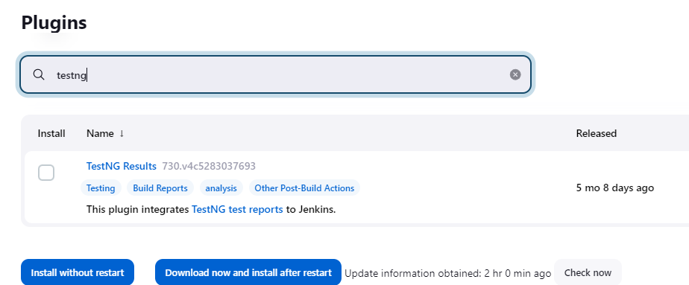

To provide an example of using the TestNG plugin in Jenkins with a Git repo, here are the general steps you can follow:

1. Install the TestNG plugin as described in the previous answer.
2. Set up a Jenkins job for your Git repo by selecting "New Item" from the Jenkins dashboard and choosing "Freestyle project" or "Pipeline".
3. In the job configuration, go to the "Source Code Management" section and select "Git".
4. Enter the URL of your Git repository and, if necessary, credentials for accessing it.
5. In the "Build Triggers" section, configure how the job should be triggered (e.g. by a Git webhook or by a scheduled build).
6. In the "Build" section, add a build step that runs your TestNG tests. For example, you could use a Maven build step with the following command:

mvn test -Dtestng.xml=testng.xml

1. In the "Post-build Actions" section, add the "Publish TestNG Results" post-build action.
2. In the "TestNG XML report pattern" field, enter the path to the TestNG XML report file generated by your test suite. If your Maven command generates the report in the default location, you can use the following path:

javascriptCopy code

**/target/surefire-reports/testng-results.xml

1. Save your changes to the job configuration.
2. Run the job to generate TestNG reports. The TestNG reports can be accessed by clicking on the "TestNG Results" link in the left-hand menu of the Jenkins dashboard.

That's it! This is a basic example of how to set up the TestNG plugin in Jenkins with a Git repo. Of course, the specifics may vary depending on your particular project and testing setup.

Finbug plugin

1. Log in to your Jenkins server and go to the "Manage Jenkins" page.
2. Click on the "Manage Plugins" link and search for the FindBugs plugin.
3. Select the FindBugs plugin and click on the "Install" button.
4. Once the installation is complete, restart Jenkins to activate the plugin.
5. Create a new Jenkins job or open an existing one that has Java code.
6. In the job configuration, go to the "Build" section and add a new build step to execute the FindBugs analysis. You can do this by adding a "Execute Shell" build step and running the following command:

findbugs -textui -xml -output findbugs-report.xml your-java-code-dir

This command will run the FindBugs analysis on your Java code in the specified directory and generate an XML report in the **findbugs-report.xml** file.

1. In the job configuration, go to the "Post-build Actions" section and click on the "Add post-build action" button.
2. Select the "Publish FindBugs analysis results" option from the list of available post-build actions.
3. In the "FindBugs pattern" field, enter the following path:

bashCopy code

**/findbugs-report.xml

This path will look for the FindBugs report file in the workspace directory of the Jenkins job.

1. Optionally, you can configure other options for the FindBugs report, such as the minimum priority for issues to include in the report.
2. Save your changes to the job configuration.
3. Run the job to generate the FindBugs report. The FindBugs report can be accessed by clicking on the "FindBugs Warnings" link in the left-hand menu of the Jenkins dashboard.

The Cobertura plugin in Jenkins is used to generate code coverage reports based on Cobertura analysis results. Cobertura is a code coverage tool that helps to identify how much of the code is covered by unit tests. The Cobertura plugin can be used to analyze Java code in Jenkins and generate reports that highlight code coverage and identify areas where additional unit tests may be needed.

To set up the Cobertura plugin in Jenkins, follow these steps:

1. Log in to your Jenkins server and go to the "Manage Jenkins" page.
2. Click on the "Manage Plugins" link and search for the Cobertura plugin.
3. Select the Cobertura plugin and click on the "Install" button.
4. Once the installation is complete, restart Jenkins to activate the plugin.
5. Create a new Jenkins job or open an existing one that has Java code.
6. In the job configuration, go to the "Build" section and add a new build step to execute the Cobertura analysis. You can do this by adding a "Execute Shell" build step and running the following command:

Copy code

mvn clean cobertura:cobertura

This command will run the Cobertura analysis on your Java code and generate a coverage report in the **target/site/cobertura** directory.

1. In the job configuration, go to the "Post-build Actions" section and click on the "Add post-build action" button.
2. Select the "Publish Cobertura Coverage Report" option from the list of available post-build actions.
3. In the "Cobertura xml report pattern" field, enter the following path:

javascriptCopy code

**/target/site/cobertura/coverage.xml

This path will look for the Cobertura coverage report file in the workspace directory of the Jenkins job.

1. Optionally, you can configure other options for the Cobertura report, such as the minimum coverage percentage required.
2. Save your changes to the job configuration.
3. Run the job to generate the Cobertura report. The Cobertura report can be accessed by clicking on the "Coverage Report" link in the left-hand menu of the Jenkins dashboard.

Top of Form